AI Study & Productivity Assistant: Project Design Document
UMGC 495 Section 6381
University of Maryland Global Campus
Victor Rosario
Akshay Sonilal-Rambarran
Jorge Armijosmurillo
01/28/2026

CMSC 495 Phase I Source Code
Introduction
This Phase I Source Code establishes the foundational implementation of the AI Study & Productivity Assistant, a web-based academic productivity system designed to support college students in managing coursework, deadlines, and study activities. Phase I focuses on project setup, core backend functionality, environment configuration, and collaborative development practices that will support future expansion.
The objective of this phase is to translate project design concepts into a working software foundation, ensuring that development tools, architecture, and workflows are properly established before advanced features are introduced.
Project Set up

  - Development Environment
The development environment was established using standard tools to ensure portability, collaboration, and maintainability. The project is implemented in Python 3.14 using the Flask web framework.
The following tools and technologies were configured:
- Python 3 for backend development
- Flask for web application routing and request handling
- Flask-Login for user authentication management
- Flask-SQLAlchemy for database modeling and ORM support
- SQLite as the initial development database
- Git & GitHub for version control and team collaboration
- Visual Studio Code as the primary development IDE
A Python virtual environment (venv) was created to isolate project dependencies. All required libraries are documented in a requirements.txt file, enabling consistent setup across team members’ systems.
  - Repository Structure
The project follows a modular directory structure to improve readability and maintainability:
- app/ – Core application package (routes, models, AI logic)
- templates/ – HTML templates for the user interface
- tests/ – Unit tests implemented with pytest
- instance/ – Local database files
- run.py – Application entry point
- requirements.txt – Dependency definitions
- README.md – Setup instructions and workflow documentation
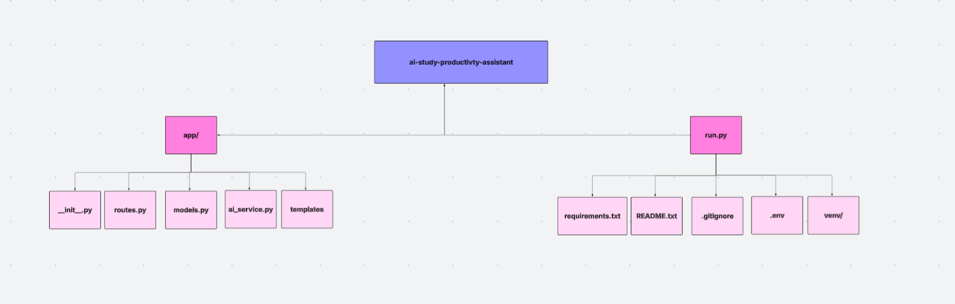
Core Functionality
3.1 Application Initialization
The application uses the Flask application factory pattern, allowing flexible configuration and easier testing. The create_app() function initializes Flask, database connections, and authentication services.
3.2 User Authentication Foundation
Initial user authentication capabilities were implemented using Flask-Login, including:
- User model definition
- Secure password hashing
- Login session handling
- Access control for protected routes
This provides the foundation for future features such as dashboards and personalized study plans.
3.3 Database Models
Core database models were created using SQLAlchemy, including:
- User: Stores user credentials and account data
- Assignment (planned): Will store coursework deadlines and tasks
- StudyPlan (planned): Will store AI-generated study schedules
3.4 AI Integration (Initial)
An AI service module (ai_service.py) was created to encapsulate communication with the OpenAI API. While advanced AI features will be expanded in later phases, So far this confirms:
- API key configuration via environment variables
- Basic AI request handling structure
- Separation of AI logic from routes and models
4. Unit Testing (Initial Validation)
Unit testing was implemented using the pytest framework to validate the correctness and stability of the source code. Testing was performed locally within the configured Python virtual environment, and all tests executed successfully.
Test Case 1: Application Initialization
Description | Verifies that the Flask application is successfully created using the application factory pattern.
Module Tested | app/__init__.py
Test Input | Call to create_app()
Expected Result | Flask application instance is created without errors
Actual Result
  Application initialized successfully
Test Status | Passed
Test Case 2: User Model Creation
Description | Validates that a User object can be instantiated with the correct attributes.
Module Tested | app/models.py
Test Input | Username, email, password
Expected Result | User object is created with correct attribute values
Actual Result
  User attributes match expected values
Test Status | Passed

Test Case 3: Assignment Creation Functional Validation
Description | Verifies that an Assignment object is created correctly and stores assignment-related data.
Module Tested | app/models.py
Test Input
  Title, description, due date, priority, user ID
Expected Result | Assignment attributes validated successfully
Actual Result
  Assignment attributes validated successfully
Test Status | Passe
Test case 1: Unit Test – Pytest Execution
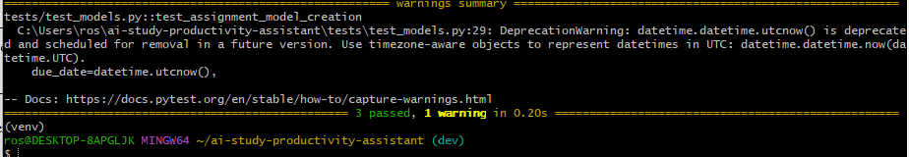
Test Case 2: Unit Test – Structure
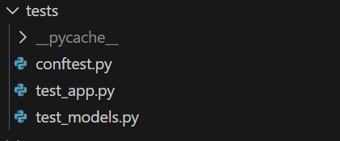
Test Case 3: Functional Validation – UI
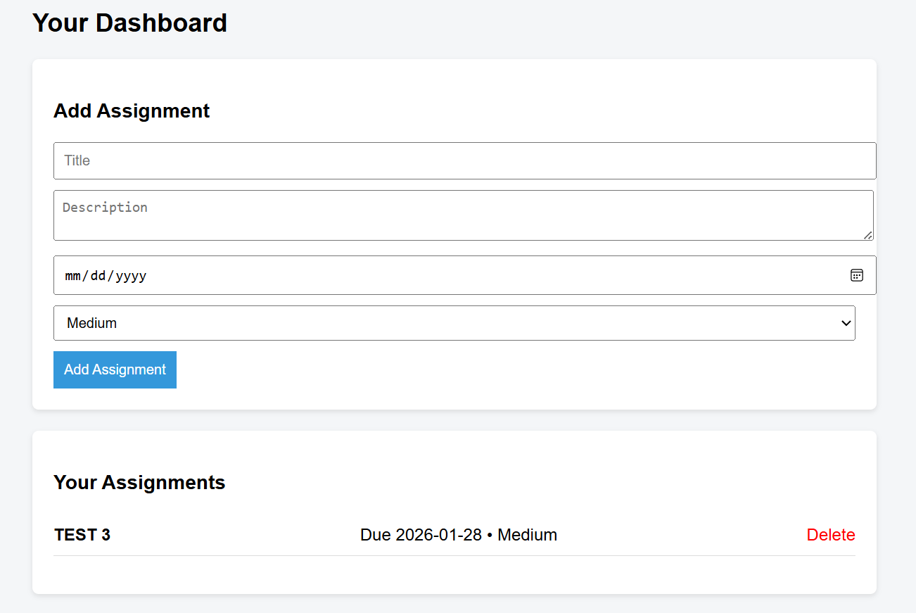
Run.py – Website on local host as logged in user.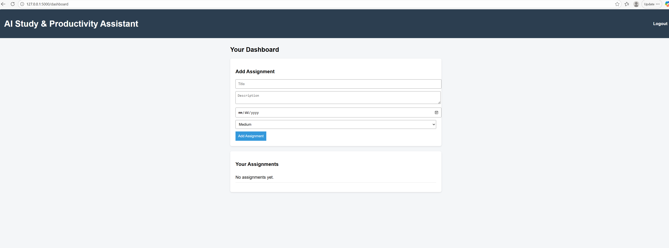

Documentation
5.1 Code Documentation
- Inline comments explain key functions and classes
- Clear naming conventions improve readability
- Modular file organization reduces complexity
5.2 External Documentation
The README.md file documents:
- Project overview
- Development setup instructions
- Git workflow rules
- Branching strategy
- Environment configuration guidelines
Collaboration and Version Control
The team used GitHub to coordinate development and maintain code integrity.
6.1 Branching Strategy
- main: Stable production-ready code
- dev: Active integration branch
- feature: Individual feature development branches
All changes are merged via pull requests to ensure code review and prevent conflicts.
6.2 Collaboration Practices
- Regular commits with descriptive messages
- Pull requests for feature integration
- Conflict resolution through rebasing
- Shared coding standards
Conclusion
Phase I successfully established the technical and collaborative foundation for the AI Study & Productivity Assistant. By implementing core backend functionality, configuring development tools, and enforcing version control best practices, the team ensured the project is well-positioned for future growth and feature expansion.

